**Big Data Analytics**

**Lab 2**

I have used Andriod phone and sensor tag device to do this experiment. I have modified the code given in the tutorial and formed new code. I generated code which measures temperature, humidity, gyroscope and pressure using the services from tutorials. I downloaded the zip folder files to generate the code. And, I used eclipse to run this program and output is GPS, accelerometer and also humidity sensors.

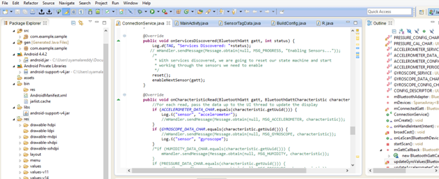

All the files are attatched to github. You can see every result in it clearly.

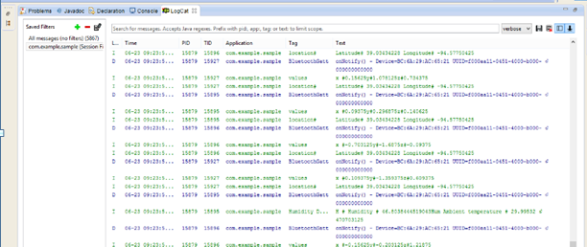

I run all the code and it successfully generated the result for temperature, humidity etc.

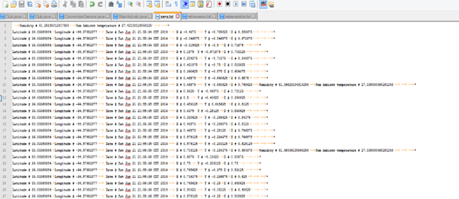

**Now, the next task is to upload data into HBase**

HBase is a cloudera manager. I developed the HBaseclient.java file and imported it into HBase.

I successfully created a HBase table named Group1 Sensor Table (any arbitrary name) and fed the data into it.

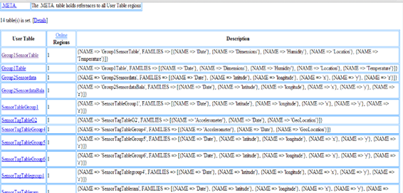

I retrieved the data entries using retrievetable( ).

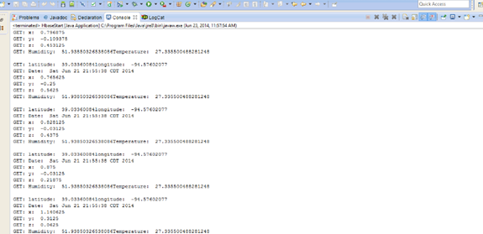

Using getalltable(), data from all rows is retrieved.

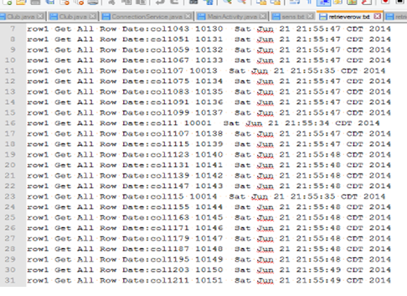

This is how we create, delete and update the data using HBase.